This activity is designed to simulate the scenario-agnostic nature of search algorithms and give students a first-person perspective of the information available in each state. Students are used to seeing state-space graphs and search trees from a birds-eye view, where all connections and state information is available at once. An AI agent using a search algorithm does not have the same perspective. In prior semesters, we have observed that students often do not understand how an agent can make decisions only seeing one state at a time, when they, as humans, can see all states and connections in the search graph. Students also often misunderstand the value of a heuristic as an estimate and instead try to compute the actual distance of a state to the goal, rather than using local state information to estimate the distance. This activity is designed to combat these misunderstandings before students try to code an agent.
Students form groups of 4-7. Each student in the group has a role. Each role has access to a subset of information about the state. The roles are:

- The Successor Dictionary
  - This role has access to all the connections in the state space graph in the form of a dictionary. When asked about a particular state, this role looks up the state in the dictionary and reports all of the connections. If the scenario includes weighted edges, the weights are included. If the connections are specific actions, the name of those actions are included (e.g., `pick up the coin', or `open the door').
  - Input: a state name/id
  - Output: all the successors of that state and the actions/costs to get there
- The Frontier
  - This role's behavior depends on the kind of list being implemented. This role uses a stack of index cards to keep track of states to be visited. If simulating Breadth-First Search, they use a First-In-First-Out (FIFO) queue. If simulating Depth-First Search, they use a Last-In-First-Out (LIFO) stack. If simulating A* or Uniform Cost Search, they use a priority queue.
  - Input: a state name/id and action
    - FIFO: Write the state name and the parent name on an index card and add it to the end of the list.
    - LIFO: Write the state name and the parent name on an index card and add it to the front of the list.
    - Priority Queue: Write the state name and the parent name on an index card. Write the total cost to get from the starting state to the current state as `g'. If using a heuristic, write the heuristic's value as `h'. On the back of the card, write the total estimated path cost `g' + `h'. Insert the card into the list based on lowest total estimated path cost
  - Output: a state's information, removed from the list appropriately
- The Goal Test
  - This role is aware of goal conditions. If the goal is a single state, this role knows the state id. If the goal is a set of state information (e.g., `You win when you are within 10 miles of Budapest.' or `The key is in your inventory and you returned to the start.'), this role process each state to see if the goal conditions have been met.
  - Input: a state name/id
  - Output: Yes or No, if that state meets the goal conditions
- The Visited Set
  - This role keeps track of which states have been inspected and ensures each path is visited only once. Can be combined with the Goal Test or Frontier role.
- The Heuristic
  - This role is only used when simulating search algorithms that use a heuristic to select states. This role has access to the birds-eye view of the state graph, however, all connections have been removed. This role must estimate the utility of inspecting each state according to its physical distance from the goal state or by examining state detail and grading how well it matched up with the goal state. Add on to the Goal Test when working with informed search.
  - Input: a state name/id
  - Output: a numerical estimate for how far this state is from the goal state
- The Search Tree
  - This role listens to the other roles and draws out the search tree. When the Goal Test says that the goal has been found, this role uses the search tree to describe the path (a list of actions to take) from the start state to the goal state. Can combine with The Algorithm.
  - Output: A path from the start state to the goal state and a list of explored states in the order you explored them.
- The Algorithm
  - This role orchestrates the algorithm's functionality by utilizing all the other roles. This role follows the pseudocode and gives each role the appropriate input. Suggest that the instructor play this role initially in a full-class demonstration before passing this role off to student groups.
  - Input: a starting state name/id

Within the student groups, work through different scenarios, starting from the traditional abstract view of search (i.e., find a path from S to G, state information and actions are abstracted) and slowly adding in complications like action names, goal conditions, and state information. Change the algorithm by changing the Frontier's behavior. Add path weights and the Heuristic role to simulate informed search algorithms. This activity is designed to be repeated multiple times on multiple days to support understanding the variety of search algorithms that depend on the same structure, but have different behaviors and solutions based on small component changes.

Sequence:
- Model with World 1. Teacher serves as the Algorithm and draws the Search Tree. Students serve as the Successor Dictionary, the Frontier, and the Goal Test.
- Uninformed
  - In student groups, work through World 2 with BFS.
  - In student groups, work through World 3 (actions!) with BFS
  - In student groups, work through World 4 with DFS
  - In student groups, work through World 5 (actions!) with DFS
  - In student groups, work through World 6 (path costs!) with UCS
  - In student groups, work through World 7 (path costs AND actions!) with UCS
- Informed
  - Model Greedy search with World 1.
  - In student groups, work through World 2 with Greedy search
  - In student groups, work through World 3 with Greedy search
  - In student groups, work through World 4 with A*
  - In student groups, work through World 5 with A*

Discussion Questions:
- How did your group organize information across the roles?
- Was there a role that was easier/harder than expected?
- In what ways was your role limited?
- How did changing the worlds change the group’s behavior?
- How did changing the roles (the Frontier’s data structure or adding heuristics) change the groups behavior?
- If you had to explain this activity to a student who missed class, how would you summarize its main goal and what you learned from it?

World 1: Simple directed graph

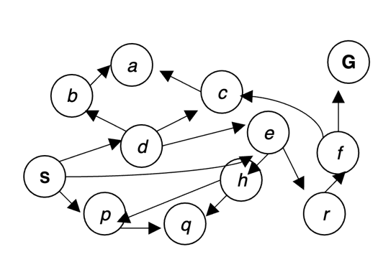

Successor Dictionary
A: none
B: A
C: A
D: B, C, E
E: H, R
F: C, G
G: none
H: P, Q
P: Q
Q: none
R: F
S: D, E, P

Start Node: S
Goal Test: goal = G
BFS visited set: S, D, E, P, B, C, H, R, Q, A, F
DFS visited set: S, P, Q, E, R, F, G

World 2: simple directed graph
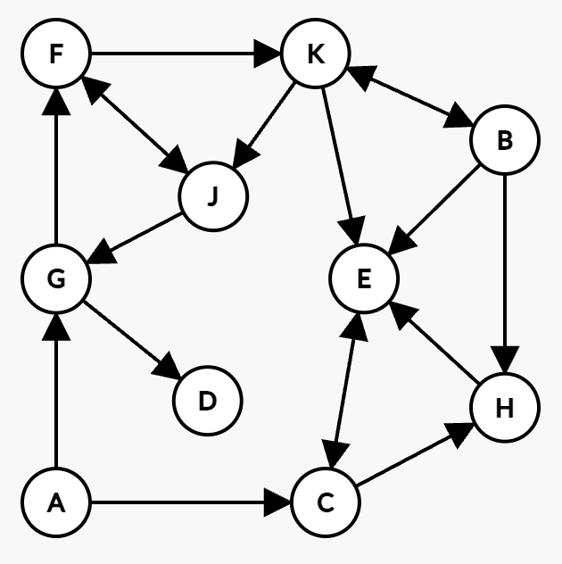
Successor Dictionary:
A: C, G
B: E, H, K
C: E, H
D: none
E: C
F: J, K
G: D, F
H: E
J: G
K: B, E, J

Start node: A
Goal Node: J

BFS visited set: A, C, G, E, H, D, F, J
BFS path: A -> G -> F -> J
World 3: simple directed graph with actions!
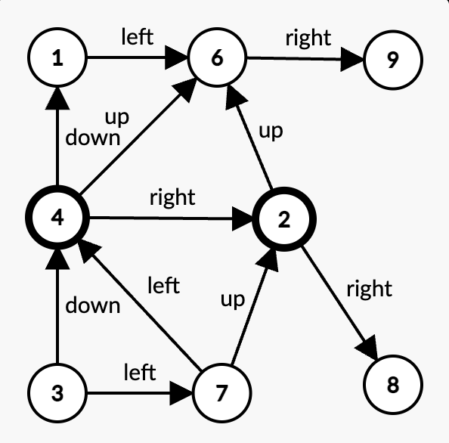

Successor Dictionary:
1: (left, 6)
2: (up, 6), (right, 8)
3: (down, 4), (left, 7)
4: (down, 1), (right, 2), (up, 6)
6: (right, 9)
7: (up, 2), (left, 4)
8: none
9: none

Start node: 3
Goal node: 9

BFS visited set: 3, 4, 7, 1, 2, 6
BFS plan: down, up, right
DFS visited set: 3, 7, 4, 6, 9
DFS plan: left, left, up, right

World 4: simple directed graph for DFS (Same as World 2 with different start/end nodes)
Successor Dictionary:
A: C, G
B: E, H, K
C: E, H
D: none
E: C
F: J, K
G: D, F
H: E
J: G
K: B, E, J

Start node: B
Goal Node: D

DFS visited set: B, K, J, G, F, D
DFS plan: B -> K -> J -> G -> D

World 5: simple directed graph for DFS
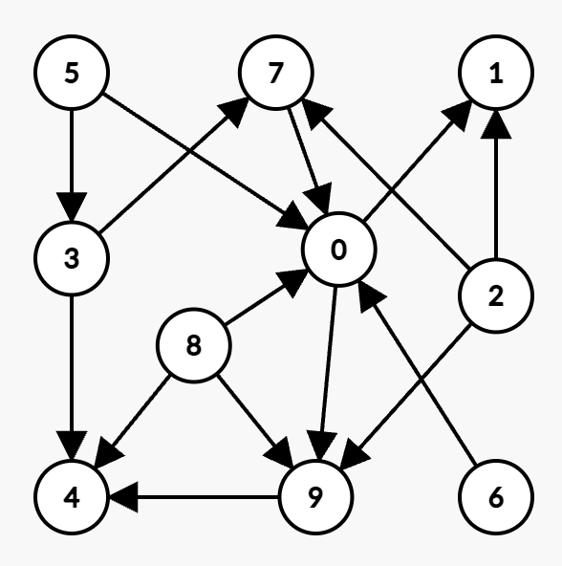

Successor Dictionary:
0: 1, 9
1: none
2: 1, 7, 9
3: 4, 7
4: none
5: 0, 3
6: 0
7: 0
8: 0, 4, 9
9: 4

Start node: 5
Goal node: 1

DFS visited set: 5, 3, 7, 0, 9, 1
DFS plan: 5, 3, 7, 0, 1

World 6: Simple weighted directed graph
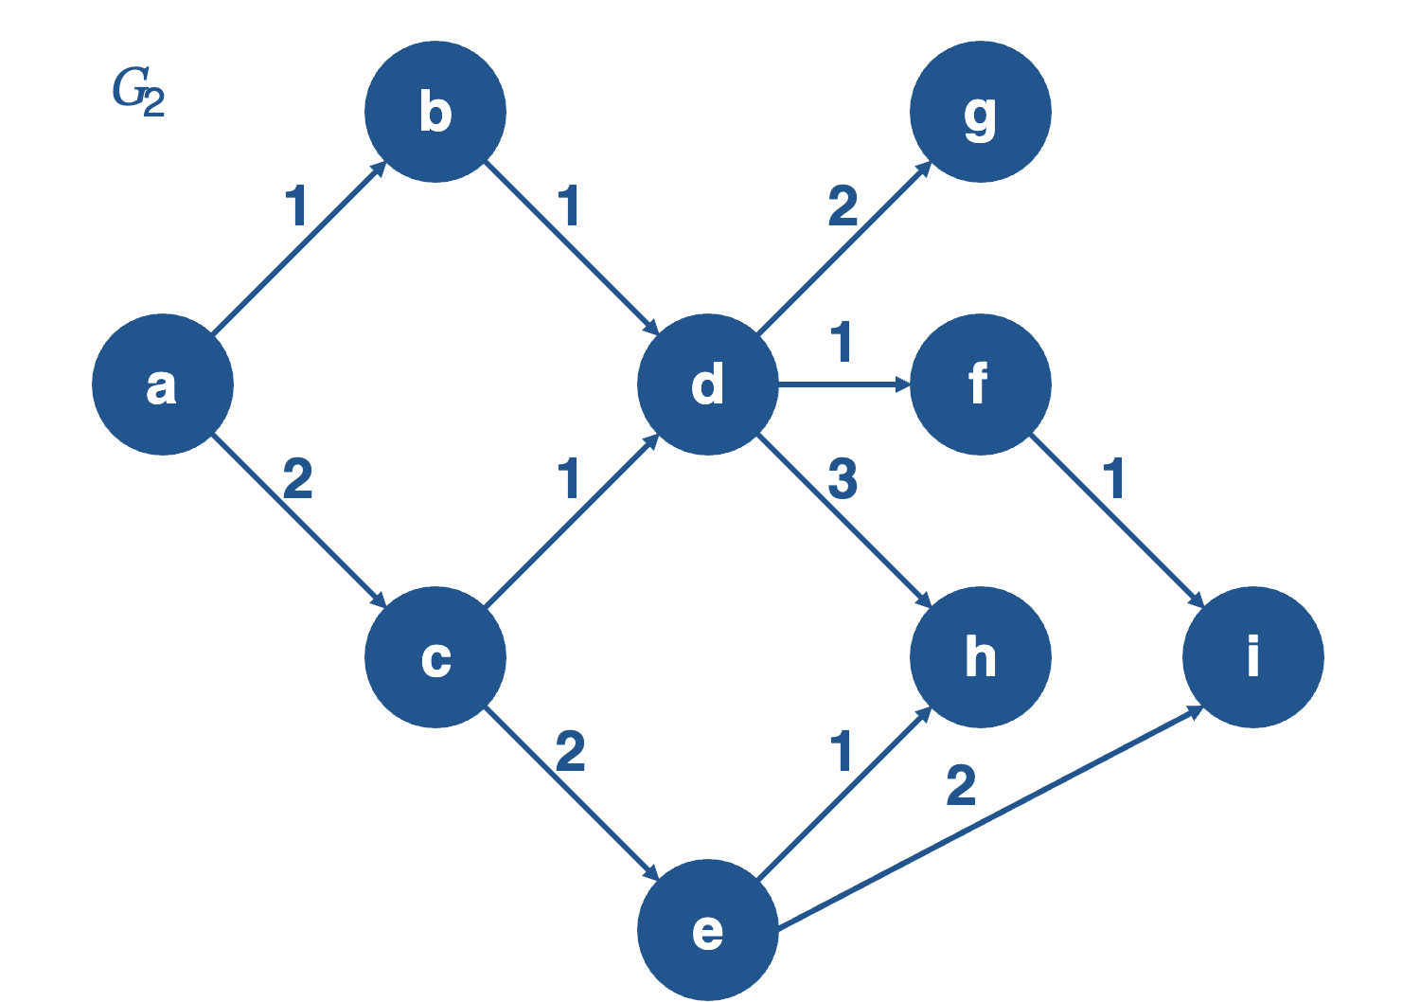
Successor Dictionary:
A: (B, 1), (C, 2)
B: (D, 1)
C: (E, 2), (D, 1)
D: (F, 1), (G, 2), (H, 3)
E: (H, 1), (I, 2)
F: (I, 1)
G: none
H: none
I: none

Start Node: A
Goal test: Goal = I

UCS visited set: A, B, C, D, E, F, G, H, I
UCS plan: A -> B -> D -> F -> I

World 7: Simple weighted directed graph for UCS
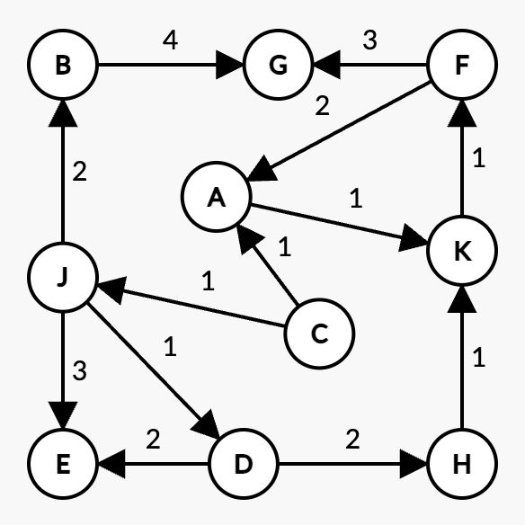
Successor Dictionary:
A: (K, 1)
B: (G, 4)
C: (A, 1), (J, 1)
D: (E, 2), (H, 1)
E: none
F: (A, 2), (G, 3)
G: none
H: (K, 1)
J: (B, 2), (D, 1), (E, 3)
K: (F, 1)

Start node: C
Goal node: G
UCS visited set: C, A, J, K, D, B, F, H, E, G
UCS plan: C -> A -> K -> F -> G

HEURISTIC SEARCH
World 1
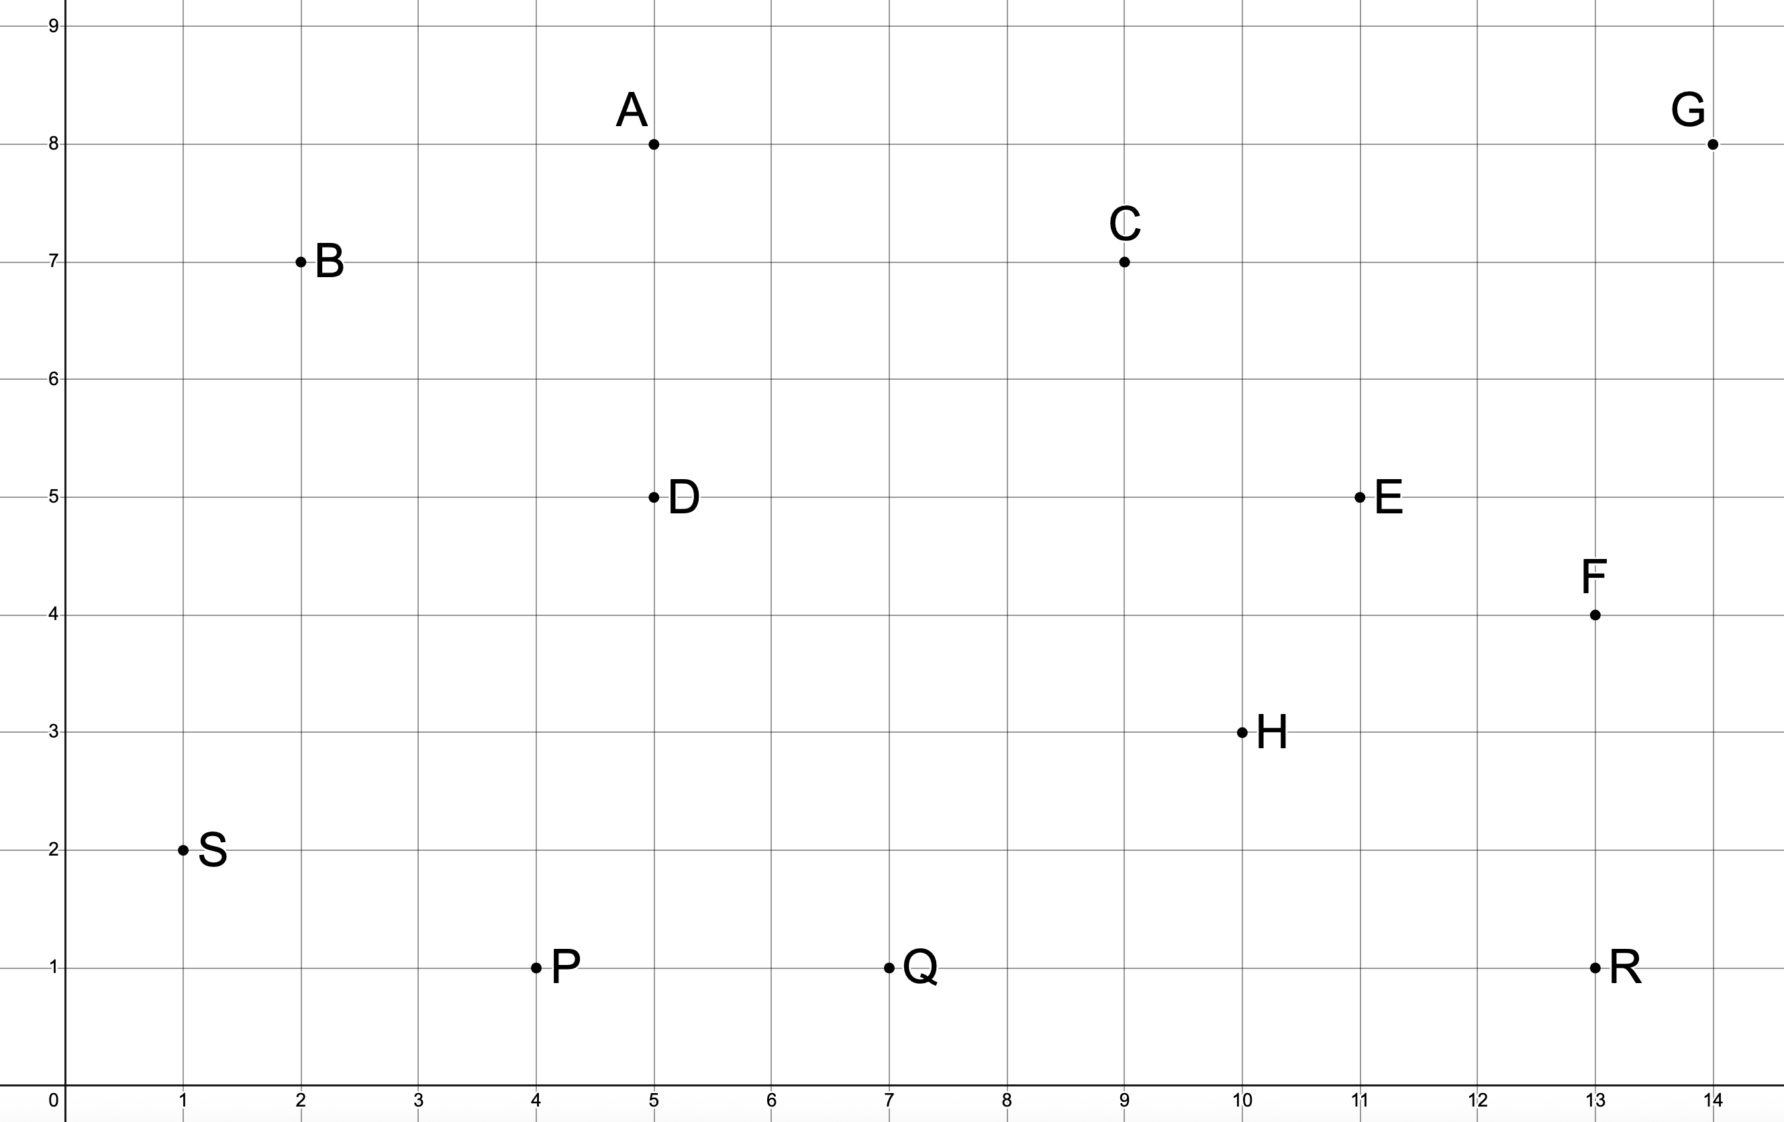
Successors Dictionary:
A: none
B: (A, 5)
C: (A, 6)
D: (B, 6), (C, 7), (E, 7)
E: (H, 4), (R, 7)
F: (C, 8), (G, 6)
G: none
H: (P, 9), (Q, 6)
P: (Q, 4)
Q: none
R: (F, 4)
S: (D, 8), (E, 14), (P, 4)
Start Node: S
Goal Test: goal = G
Greedy path: S -> E -> R -> F -> G
Greedy visited set: S, E, R, F, G
Cost: 31

World 2
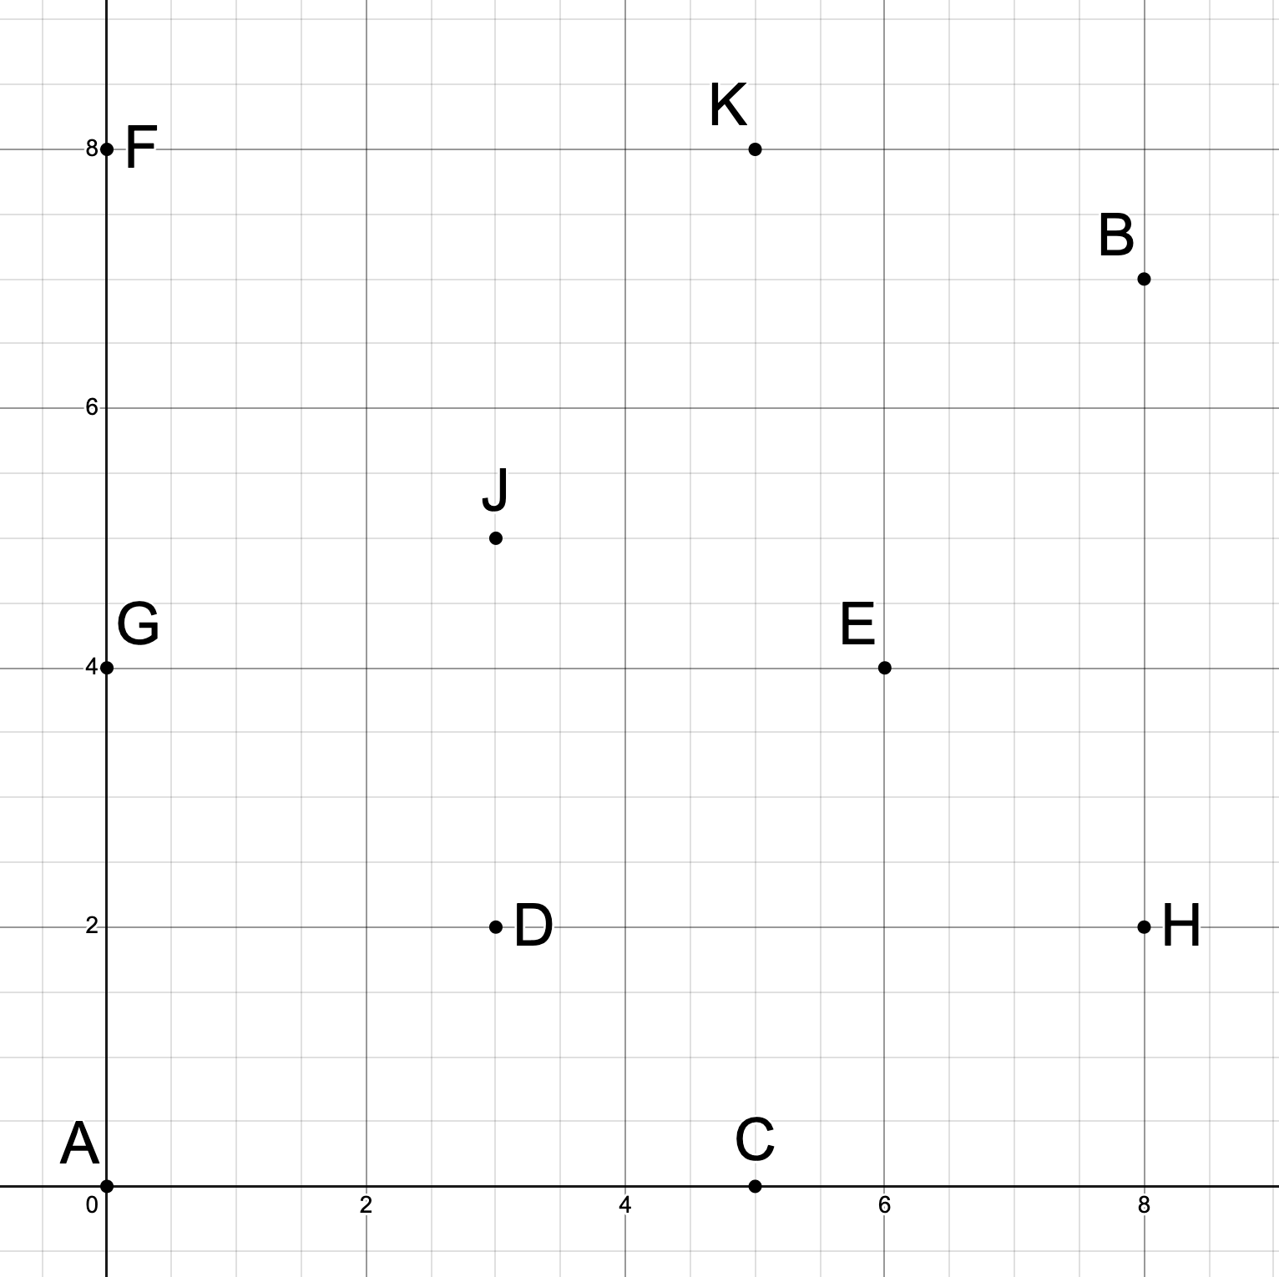
Successor Dictionary:
A: (C, 6), (G, 5)
B: (E, 6), (H, 6), (K, 5)
C: (E, 6), (H, 6)
D: none
E: (C, 6)
F: (J, 7), (K, 6)
G: (D, 6), (F, 5)
H: (E, 5)
J: (G, 5)
K: (B, 5), (E, 6), (J, 5)

Start node: A
Goal Node: J

Greedy visited set: A, G, D, F
Greedy path: A -> G -> F -> J
Cost: 17
World 3: simple directed graph with actions!
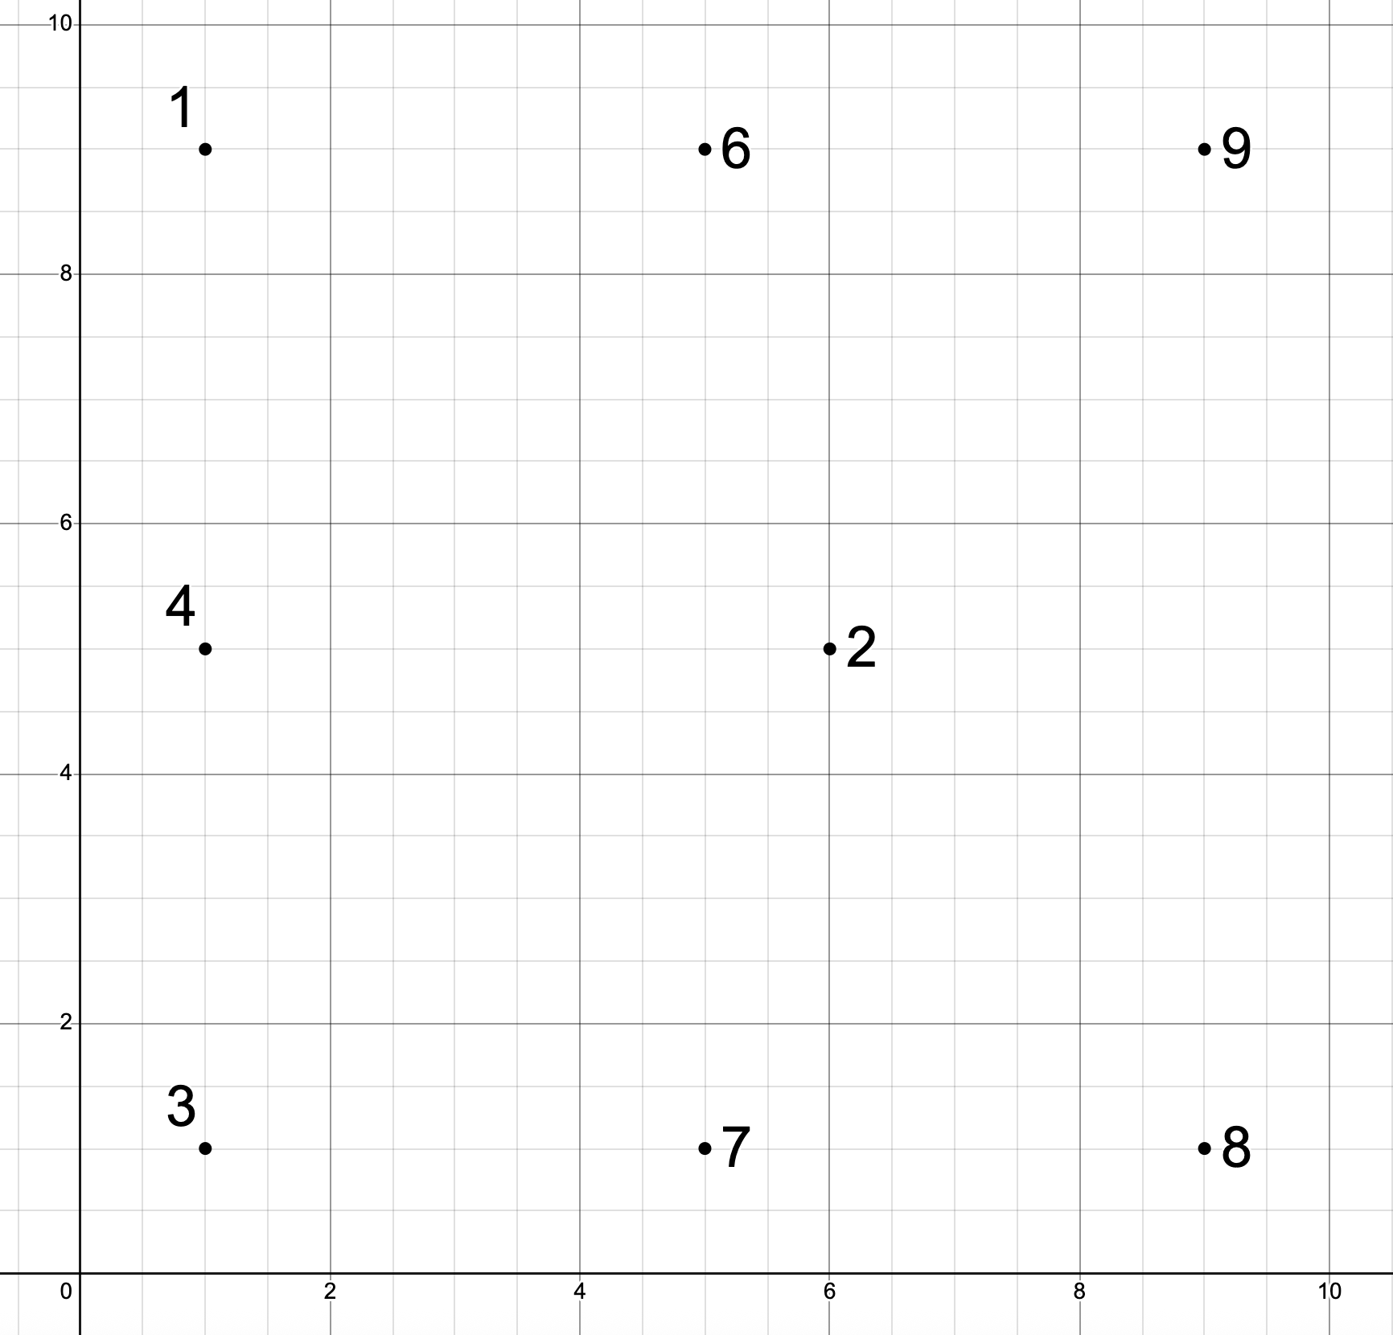

Successor Dictionary:
1: (left, 6, cost=5)
2: (up, 6, cost=6), (right, 8, cost=8)
3: (down, 4, cost=5), (left, 7, cost=4)
4: (down, 1, cost=4), (right, 2, cost=6), (up, 6, cost=9)
6: (right, 9, cost=5)
7: (up, 2, cost=6), (left, 4, cost=9)
8: none
9: none

Start node: 3
Goal node: 9

Greecy visited set: 3, 4, 6, 9
Greedy plan: down -> up -> right
Cost: 19

World 4: (previous World 6)
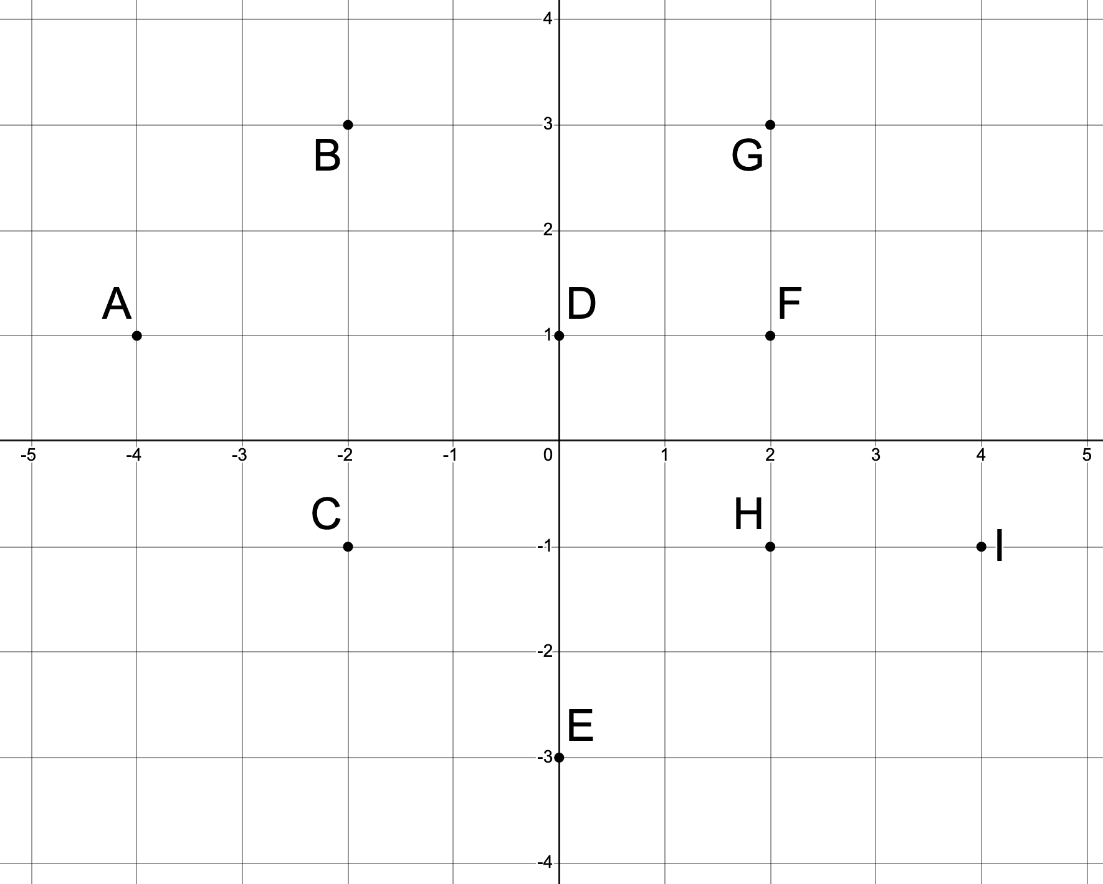
Successor Dictionary:
A: (B, 7), (C, 5)
B: (D, 5)
C: (E, 6), (D, 7)
D: (F, 3), (G,5), (H, 5)
E: (H, 7), (I, 7)
F: (I, 7)
G: none
H: none
I: none

Start Node: A
Goal test: Goal = I

A* visited set: A, C, B, E, D
A* plan: A -> C -> E -> I
Cost: 18

World 5: (same as prev World 7)
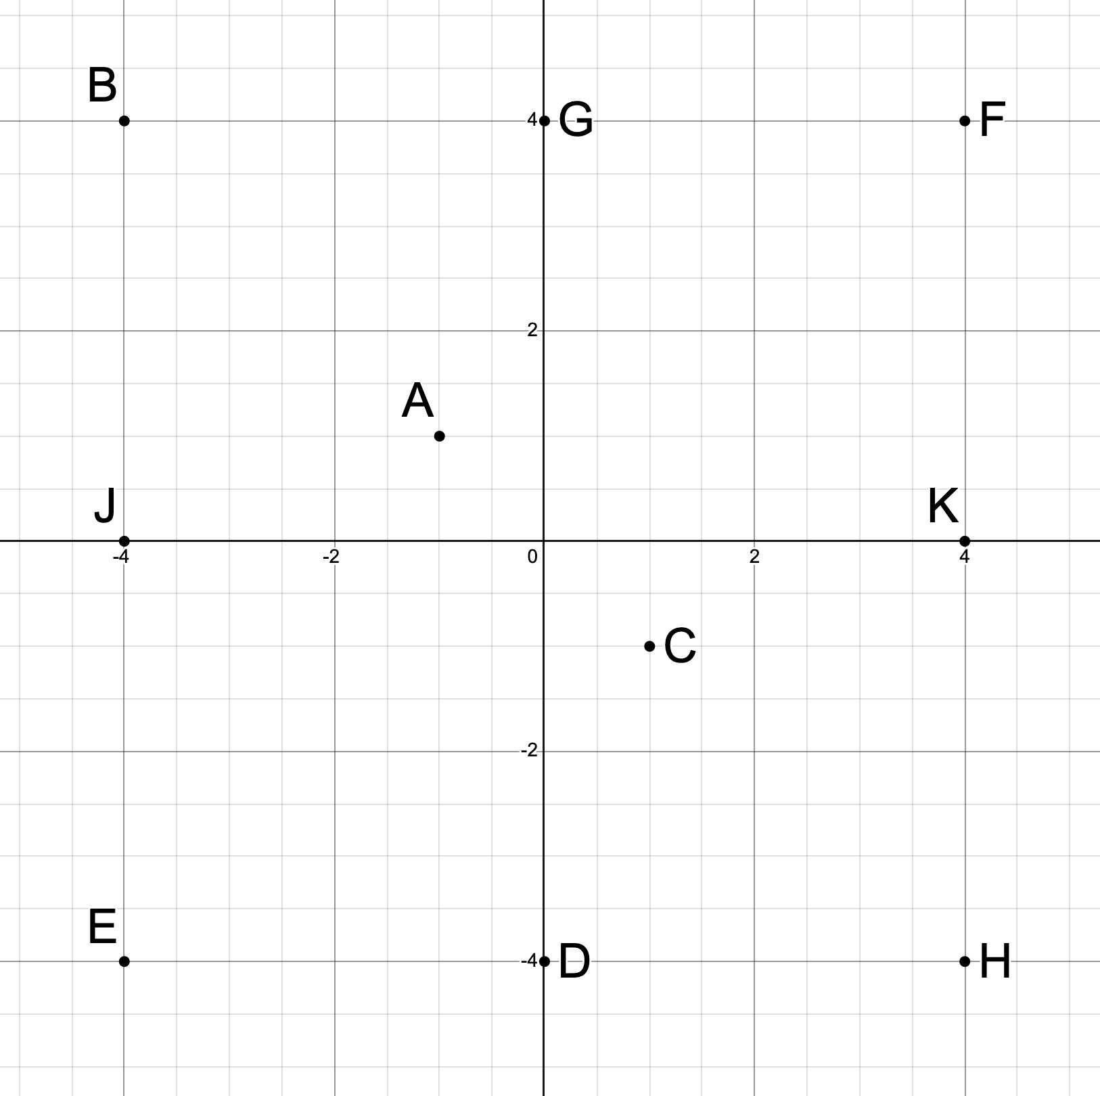
Successor Dictionary:
A: (K, 9)
B: (G, 5)
C: (A, 5), (J, 9)
D: (E, 7), (H, 5)
E: none
F: (A, 10), (G, 6)
G: none
H: (K, 8)
J: (B, 5), (D, 12), (E, 7)
K: (F, 8)

Start node: C
Goal node: G
A* visited set: C, A, J, B
A* plan: C -> J -> B -> G
Cost: 19

